Name: ____________________________________________________________ Date: ______________ Period: ______

Plate Tectonics

[Plate Tectonics Website: http://education.sdsc.edu/optiputer/flash/convection.htm](http://education.sdsc.edu/optiputer/flash/convection.htm)

Before watching the simulation: Make a prediction, which way will the green plates move? Why?

Label the direction the crust will go on the following diagram:

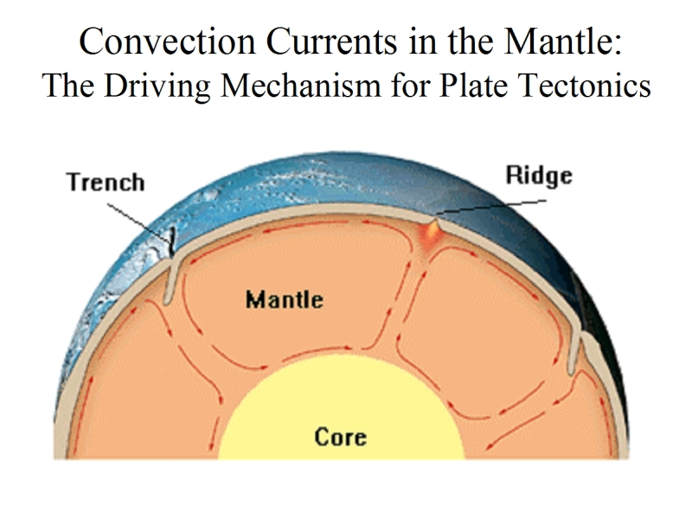

| **Plate Boundary** | **Sketch** | **Definition** | **Real World Example** |
| --- | --- | --- | --- |
| Convergent |  | Place where 2 plates move ____________________  Where ________________ or __________________ can form | Nazca Plate and South American Plate are moving toward each other |
| Divergent |  | Place where two plates move _______________  Where new __________ is formed | Mid Atlantic Ridge  Two oceanic plates are moving away from each other—forms a ridge |
| Transform |  | Place where 2 plates ______________ past each other  Where _________________ occur | North American and Pacific Plates are sliding past each other—creates earthquakes |

**Practice:**

1. What is plate tectonics?
2. What are the three types of plate boundaries?
3. What type of plate boundaries form volcanoes?
4. What type of plate boundaries cause earthquakes?

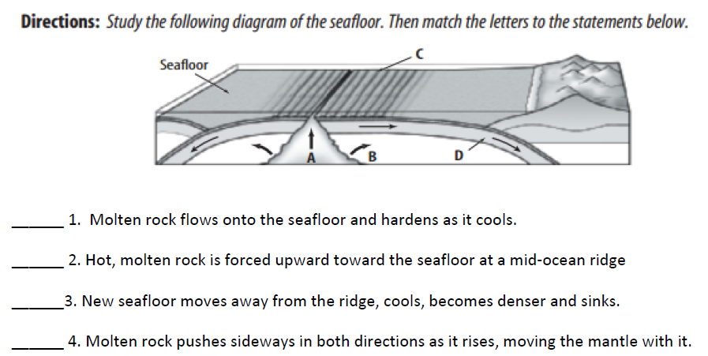

For the diagrams below, label the type of boundary, then draw in the convection currents below each plate that cause that kind of motion.

